# DECLARATION

I, AYUKANYOR EXCELLENT EPEINJANG successfully undertook a one month internship on the topic “DESIGN AND IMPLEMENTATION OF LIBRARY MANAGEMENT SYSTEM” study BRIDGEAFRICA. I therefore declare, this project is my personal work, All what have been copied from others works have been referenced.

SIGNATURE: __________________________________________

DATE: _______________________________________________

# CERTIFICATION

This is to certify that this piece of work title **“**LIBRARY MANAGEMENT SYSTEM**”.** is written by AYUKANYOR EXCELLENT EPEINJANG. All borrowed ideas have been acknowledged by means of references.

SUPERVISOR: MR SHIYNSA CHARLES

SIGNATURE: _______________________________________

DATE: _________________________________________

# DEDICATION

To EPEINJANG’S FAMILLY.

# ACKNOWLEDGEMENTS

-I am greatful to the founders and board of directors that have founded a school like CITEC which has provided me with a conducive atmosphere to study

-All my gratitude goes to my academic supervisor **MR SHIYNSA CHARLES** for his support, guidance, time and energy in order to make this project a success.

-Special thanks to my lecturers who have been amazingly supportive especially, **MR TANYI ABANG**, for impacting me with the knowledge to identify some problems I needed to adjust in my project.

-For the moral and material support and for being an exemplary father. Thanks to my brothers for the emotional support and constant encouragement. And to my friends and classmates who inspired me Thank you very much.

**-** Thanks to my classmates with whom I shared ideas on different possible solutions

**-** Thanks to my mum for the support both morally and financially

# ABSTRACT

A Library Management System is a computerized system which helps users (librarian) to manage the library daily activity in electronic format.The system would provide basic set of features to add/update members, add/update books, and manage check in specifications for the systems based on the client's statement of need.It helps the Administrator to maintain the database of new books and the books that are borrowed by members along with their due dates. Library management system is a typical management Information system (MIS), its Development include the establishment and maintenance of back-end database and front-end application development aspects. For the former require the establishment of data consistency and integrity of the strong data security and good libraries. As for the latter requires the application fully functional, easy to use and so on. Management software for monitoring and controlling the transactions in a library. The project “Library Management System” is developed in PHP, MySql, HTML, CSS, XAMP which mainly focuses on basic operations in a library like adding new books, and updating new information, searching books and members and return books. This project of “LIBRARY MANAGEMENT” of gives us the complete information about the library. We can enter the record of new books and retrieve the details of books available in the library. We can issue the books to the students and maintain their records and can also check how many books are issued and stock available in the library. User can successfully research for a specific book. The methodology used is OMT .In this project we can maintain the late fine of students who returns the issued books after the due date. Throughout the project, the focus has been on presenting information and comments in an easy and intelligible manner. This project is very useful for those who want to know about a Library Management System. With the help of the administrator, a user can successfully login into system. A book search can be successfully carried out on the system when a particular book is to be signed out by a student.

# RESUME

Un système de gestion de bibliothèque en ligne est un système informatisé qui aide l'administrateur (bibliothécaire) à gérer l'activité quotidienne de la bibliothèque sous forme électronique. Le système fournit un ensemble de fonctions de base pour ajouter/mettre à jour les membres, ajouter/mettre à jour les livres, et gérer les spécifications d'enregistrement pour les systèmes basés sur l'énoncé des besoins du client. Il aide l'administrateur à maintenir la base de données des nouveaux livres et des livres empruntés par les membres avec leur date d'échéance. Le système de gestion de bibliothèque est un système d'information de gestion (SIG) typique, dont le développement comprend l'établissement et la maintenance d'une base de données dorsale et les aspects de développement d'une application frontale. Pour le premier, il faut assurer la cohérence et l'intégrité des données, une bonne sécurité des données et de bonnes bibliothèques. Pour le second, l'application doit être pleinement fonctionnelle, facile à utiliser, etc. Logiciel de gestion pour le suivi et le contrôle des transactions dans une bibliothèque. Le projet "Système de gestion de bibliothèque" est développé en PHP, MySql, HTML, CSS, XAMP qui se concentre principalement sur les opérations de base dans une bibliothèque comme l'ajout de nouveaux livres, et la mise à jour de nouvelles informations, la recherche de livres et de membres et le retour de livres. Ce projet de "GESTION DE BIBLIOTHÈQUE" nous donne des informations complètes sur la bibliothèque. Nous pouvons saisir l'enregistrement des nouveaux livres et récupérer les détails des livres disponibles dans la bibliothèque. Nous pouvons distribuer les livres aux étudiants et maintenir leurs dossiers, et nous pouvons également vérifier le nombre de livres distribués et le stock disponible dans la bibliothèque. L'utilisateur peut rechercher avec succès un livre spécifique. La méthodologie utilisée est l'OMT. Dans ce projet, nous pouvons gérer les amendes de retard des étudiants qui rendent les livres délivrés après la date d'échéance. Tout au long du projet, l'accent a été mis sur la présentation des informations et des commentaires d'une manière simple et intelligible. Ce projet est très utile pour ceux qui veulent connaître un système de gestion de bibliothèque. Avec l'aide de l'administrateur, un utilisateur peut se connecter au système. Une recherche de livres peut être effectuée avec succès sur le système lorsqu'un livre particulier doit être retiré par un étudiant.

Table of Contents

DECLARATION i

CERTIFICATION ii

DEDICATION iii

ACKNOWLEDGEMENTS iv

ABSTRACT v

RESUME vi

CHAPTER 1: INTRODUCTION AND PRESENTATION OF ENTREPRISE 1

1.1 BACKROUND OF STUDY 1

1.1.1 HISTORICAL BACKGROUND 1

1.1.2 CONCEPTUAL BACKGROUND 2

1.1.3 THEORETICAL BACKGROUND 3

1.1.4 CONTEXTUAL BACKGROUND 4

1.2 STATEMENT OF THE PROBLEM 5

1.3 OBJECTIVE OF THE STUDY 5

1.3.1 MAIN OBJECTIVE 5

1.3.2 SPECIFIC OBJECTIVES 5

1.4 RESEARCH QUESTION 6

1.4.2 SPECIFIC QUESTION 6

1.5 RESEARCH HYPOTHESIS 6

1.5.1 SPECIFIC HYPOTHESIS 6

1.6 SIGNIFICANCE OF STUDY 7

1.6.1 TO USERS 7

1.7 JUSTIFICATION OF STUDY 7

1.8 SCOPE OF THE STUDY 7

1.8.1 THEMATIC SCOPE 7

1.8.2 GEOGRAPHICAL SCOPE 7

1.8.3 TIME SCOPE 7

1.9 ORGANISATION OF STUDY 8

Chapter 2: LITERATURE REVIEW 8

2.1 THEORETICAL REVIEW 8

2.2 CONCEPTUAL REVIEW 9

2.3 EMPERICAL REVIEW 10

2.4 PRESENTATION OF THE ENTERPRISE 11

2.4.1 PRESENTATION OF INTERNSHIP ACTIVITIES 11

2.4.2 ACTIVITIES CARRIED OUT 11

2.4.3 INTERNSHIP EXPERIENCE 11

2.4.4 STRENGTH AND WEAKNESSES 11

2.4.5 PROBLEM ENCOUNTERED 12

2.4.6 RECOMMENDATION 12

CHAPTER 3: METHODOLOGY 13

3.1 INTRODUCTION 13

3.2 THE DESCRIPTION OF THE ARCHITECTURE OF THE SYSTEM. 13

3.3 DATA COLLECTION METHOD AND USERS NEED 14

3.3.1 OBSERVATION 14

3.3.2 INTERVIEW 14

3.3.3 USERS NEED 14

3.4 FUNCTIONAL REQUIREMENT 15

3.5 FUNCTIONAL SPECIFICATION 15

3.5.1 ROLE PAYED BY EACH AUTHOR 15

3.5.2 The System's Abilities 16

3.6 TECHNICAL SPECIFICATIONS 16

3.7 NON-TECHNICAL SPECIFICATION 17

3.8 RESEARCH DESIGN 18

3.9 ANALYSIS METHODS 18

3.10 OBJECT- ORIENTED MODELING 18

3.10.1 OMT METHOD 19

3.10.2 UML METHOD 20

3.10.3 UNIFIED PROCESS METHOD 21

3.11 FUNCTIONAL METHODS 22

3.11.1 SADT METHOD 22

3.11.2 MERISE METHOD 24

3.12 CHOICE OF METHOD 25

3.13 APPLICATION OF METHOD 25

3.13.1 ACTORS 25

3.13.2 DIAGRAMS 26

3.14 VARIOUS MODEL OF THE METHOD 29

3.14.1.1 DATA DICTIONARY 29

3.14.2 RULES TO MOVE FROM ONE DATA MODEL TO ANOTHER 32

3.15 SOFTWARE USED 33

3.16 PROGRAMMING LANGUAGES USED 34

3.17 HARDWARE USED 34

3.18 MODULES OF THE DESIGNED SYSTEM 35

CHAPTER 4: PRESENTATION ANALYSIS AND PRESENTATION OF RESULTS 36

4.1 INTRODUCTION 36

4.2 RESULTS 36

4.3 PRESENTATION OF SCENARIOS 36

4.3.1 Add book Page. 37

4.3.3 Issue book Page. 38

4.3.4 Search book page 39

CHAPTER 5: DISCUSSION, CONCLUSION AND RECOMMENDATIONS 40

5.1 SUMMARY OF FINDINGS 40

5.2 DIFFICULTIES ENCOUNTERED 40

5.3 RECOMMENDATION 40

REFERENCE 41

APPENDIX 43

**Table of Figures**

Figure 1: Architecture of the system 13

Figure 2: SADT Model 23

Figure 3:Use case diagram 26

Figure 4:Sequence Diagram 27

Figure 5:Component Diagram 28

Figure 6:Add book page 37

Figure 7:Issue book page 38

Figure 8:Search book page 39

Figure 10 Add book code 43

Figure 11: Issue book code 44

Figure 12: Search book code 45

**LIST OF ABBREVIATIONS**

CSS Cascading Stylesheet

HTTP Hyper-Text Transfer Protocol

ICT Information and communication Technology

IS Information Technology

IT Information Technology

OMT Object Modeling Technique

PHP Hyper-Text Pre-processor

SADT Structure Analysis and Design

SQL Structured Query Language

UML Unified Modeling Language

UP Unified Process

URL Universal Resource Locator

WWW World wide web

XHTML Extensive Hyper-text markup language

MIS Management Information System

.

# CHAPTER 1: INTRODUCTION AND PRESENTATION OF ENTREPRISE

In these chapter, the researcher would provide the background of study, the statement of problem, the objectives of the study, research questions, significant of the study, justification of study, research hypothesis, and definition of terms and the scope of study.

# 1.1 BACKROUND OF STUDY

The background of study will involve the historical background, theoretical background, the contextual background and the conceptual background.

# 1.1.1 HISTORICAL BACKGROUND

In the latter half of the 1970s, Mittermeyer and Houser (1979) pointed out that until that time, there had been few library management theories based on research. Later on, textbooks appeared with titles that included ‘Library Management’. In much of the literature, however, business management theories were introduced with partial modifications for application to libraries, despite the fact that these theories were developed with private enterprises in mind. If the literature did not reference business management theory directed at profit-making enterprises, many of them only introduced library operations such as ‘cataloguing’ or ‘reference service’. The reasons for this disregard toward researching or theorizing about library management can be seen in McClure’s article (1982). The article presents the following ideas: library work was considered ‘woman’s work’ since it fell into the category of ‘cultural and community activities’; The library was considered to be a good thing and little justification of its existence needed to be provided; and the library was simply ‘to hold books’. The notion of the library as integral to the development of a larger institution or community was generally ignored and held only by cultural dilettantes who had nothing better to do. In brief, McClure suggests that the library world, until now, has not only ignored management theories, but management itself. Biddle (1992) pointed out a similar result in his research: ‘Little managerial expertise was required’

Nowadays in a highly tech society, human productivity is made more efficient through the development of electronic gadgets. Technologies are important and helpful in everyone's life. When systematically arranged in a room of privacy, for such collection the advance of such modernization in education, is one way to globalize the process of researchers to realize the technology is advancing at an incredibly fast paste. A library is a place in which literary and artistic material such as books, periodicals, newspapers, pamphlets, prints, records, and tapes are kept for reading, for reference, or lending.

# 1.1.2 CONCEPTUAL BACKGROUND

In this review of a Online Library Management System, we are to explain in details concepts used in our topic such as defining some concepts like explaining the meaning of design and implementation.

1. **Acquisition management module**

Libraries need to keep refreshing their resources but the full acquisition cycle is manually intensive. Keeping track of all the different cogs involved is easier with Acquisition Management Module. IT starts with the selection of resources which is done using pre-order bibliographic searching of the library catalog to avoid duplication and then

* The order is placed
* The goods are received
* Quality checked,
* Invoices processed
* Payment is made to vendors
* Records of the acquisitions are maintained
* Automatic allocation of book IDs to new acquisitions

2. **Catalog management module**

A very important feature is catalog management, the method by which metadata is created representing the knowledge resources of your library such as books, articles, documents, audio clips, maps, digital content. The software will digitally keep track of what is available in the library and catalog the content by title, subject, author and date of publishing. The system uses rack numbers and location identifiers to catalog library resources so that students and staff know exactly which shelf of which rack the book or knowledge resource they are looking for can be retrieved from.

3. **User management module**

A detailed database of users with their name, ID, login and password is created. This helps in keeping track of the member’s library usage. Also, a multi-user environment ensures that many users can use the software without speed or access issues.

4. **Online Public Access Catalog (OPAC)**

The advantage of an online public access catalog system has been highlighted during remote learning because of the pandemic.  Students can search for books, e-resources and journals from wherever they are and need not be confined to the library premises. Students will need to enter their login credentials and password via the web to access the catalog. The search results could offer students direct electronic access to the resources or give their physical location in the library.

6. **Fee management module**

The software keeps track of membership fees and manages individual student accounts. In case of unreturned, lost or damaged books, the software throws up the fine due from the student by automatically counting days from the due date. Next comes intimating the student of the fine and ensuring that until the payment is made, there are restrictions on the student using the library’s resources.

# 1.1.3 THEORETICAL BACKGROUND

Most of the concepts here are based on ideas based on the work of numerous authors. According to Robertson (2004), a Library management system such as an automated library system is a software developed to handle basic functions of a library and it provides a complete solution for the administration of a library's technical function and services to the public. A library management system is made to have fast process transaction for searching book titles, borrowing books, returning books, computing penalties, and generating an accurate report. A library management system is an important part of the educational sector as well as some professional sector as well as some professional sectors, the efficiency of a library lies on how the books are arranged and how easily one can get the books of their choice. Generally, what we can see today are manual library management system where process of some operation is very hectic. A library is a place where we get information in any format and from many sources. This involves the utilization of many processing, accessing, and retrieving the decision-making and scholastic approaches. Because of the organized approach and systematic management of the information, the accessibility and retrieval in the library can be easy. In addition, schools that are using online library would facilitate their students to reserve books in the library easier and faster. In this modern world of technological advancement, from the traditional searching process for the books in the libraries, the interactive use of computers can be now addressed as part of the library system. Now with the advent of such modernization in education, our way to globalize the process of research is to realize that technology is advancing incredibly in a fast paste. Technology has a systematic and organized way of keeping data, records, computing numbers, accomplishing a lot of transactions and reports. Students often find problems because books are limited and only few students can have the books. Students need to fall in line and then ask for the related title of the books. Through this, some students are not able to follow their lessons. The answer to this problem is the enhancement of technology by developing library management system. The efficiency of library lies on how books are arranged and how easily one can get the books of their choice. They can easily control all the students borrowing and returning the books. Library Management System is a web application which refers to library system. It is used by librarian to manage the library using a computerized system where he or she can record various transactions like issue of books, return of books, addition of new books, addition of new students etc. Books and student search modules are also included in this system which would keep track of the students using the library and also a detailed description about the books. With this computerized system there will be no loss of book record or member record which generally happens when a non-computerized system is used. In addition, report module like view returned books and borrowed books are also included in Library Management System. All these modules are able to help librarian to manage the library with more convenience and in a more efficient way as compared to library systems which are not computerized.

# 1.1.4 CONTEXTUAL BACKGROUND

Before discussing library management systems, it might help to talk about systems. A system is something formed of parts, each of which interacts with the other parts to achieve some common purpose. In the case of a library management system, the parts work together to support the management of library information resources. Their acquisition, representation and circulation. Each of these parts constitutes a subsystem which in turn comprises a set of interconnected parts. In other words, each of these subsystems can be broken down into yet smaller subsystems, for example, a subsystem to control the catalogue display options. It is worth noting that vendors of library management systems often refer to the main subsystems, such as acquisitions and circulations, as modules. A library management system is an example of an information system. An information system, whether it is computerized or not, is a system that represents objects in a physical system, for example, information resources in a library collection. The catalogue discussed in the last chapter is a system that represents the actual information resources of a library, whether that representation consists of marks on a card, marks on a microfiche sheet or data stored in a computer.

# 1.2 STATEMENT OF THE PROBLEM

An online library system is an infrastructure that allows users to search books and book content, add/remove books. The problem faced with a manual system is the difficulty in research for a specific book given that some user prefer specific authors. Also after knowing the preferred author of the book and the book title, another issue will be the specific location of that book. In this, if this problem isn’t solved the user can have issues researching for a specific information to aid in his/her research. The librarian can find it difficult to keep record of the signing in/out of books and so cause confusion. To solve this problem, the Library Management System helps to query out specific information and helps to record the signing in/out of books. All information of a specific book and the user to whom it’s issued are well recorded.

# 1.3 OBJECTIVE OF THE STUDY

The objective of a library management system is to provide a medium for the public libraries to computerize their entire functioning and would contribute as a step in digitalizing libraries.

# 1.3.1 MAIN OBJECTIVE

Looking at the main research objective, the researcher is interested investigating the extent to which the Library Management System can be used to properly manage the signing in and out of books.

# 1.3.2 SPECIFIC OBJECTIVES

The specific objectives of the study are:

* To investigate if an administrator can successfully register a new book into the system.
* To investigate if a student can successfully sign out a book with the help of the system admin.
* To examine how fast a book search can be carried out on a system when a particular book is to be signed out

# 1.4 RESEARCH QUESTION

The research questions are both general and specific.

1.4.1 GENERAL QUESION

As regards the main research question, we are aimed at examining the extent to which the system can permit the system administrator to properly manage the signing in and signing out books

# 1.4.2 SPECIFIC QUESTION

* To what extend can an administrator successfully register a book into a system.
* To what extend can a student successfully sign out a book from the system with the help of a system admin.
* To what extend can a book search be carried out on the system when a particular book is to be signed out?

# 1.5 RESEARCH HYPOTHESIS

The system can be properly used to manage the signing in and out of book

# 1.5.1 SPECIFIC HYPOTHESIS

* An administrator can successfully create a new book in the system
* With the help of a system admin, a student can successfully login into a system.
* A book search can be successfully carried out on the system when a particular book is to be signed out by a student.

# 1.6 SIGNIFICANCE OF STUDY

Library is not different from any firm institution or even an organization. If considering the use of computer to perform a given task is the topic on hand. The main purpose of a library is to provide conductive learning environment and a place for the students and clients to study.

# 1.6.1 TO USERS

This study will be a significant endeavor in promoting good working environment in schools.

This study will also be beneficial to the students and librarians.

# 1.7 JUSTIFICATION OF STUDY

I implement this system for better user experience. This system is very easy to use and access. Also for establish real time utility, using modern and updated technology. So, users can see the all the update without refresh (reload). This system should be compatible with user’s devices such as personal computers, tablets, laptops, & smart phones. So users can easily access get into the system anytime anywhere. This system is make very simple & user friendly for any user to interact with.

# 1.8 SCOPE OF THE STUDY

The scope of the study here involves the time scope, geographical scope and thematic scope.

# 1.8.1 THEMATIC SCOPE

The project is titled a library management system totally built at administrative ends and thus only the administrator is given access to create, edit and delete stuffs.

# 1.8.2 GEOGRAPHICAL SCOPE

This project was carried out in the political capital of Cameroon, precisely at Carrefour Intendance in the building Centre International D’Artisanat Du Cameroon.

# 1.8.3 TIME SCOPE

This project (the online library) took a period of 2 months. From 29th of July to 29th of August. However, these period wasn’t sufficient to carry out the scientific research.

# 1.9 ORGANISATION OF STUDY

* Chapter one which comprises of the general introduction, the background of study, problem of the statement, objective of the study, research questions, hypothesis, significant of the study, justification and scope of study.
* Chapter two is concern with the literature review which contains the theoretical review, conceptual review and empirical review
* Chapter three looks at the research methodology which include the research design of the library system, data instrument analysis and interpretation.
* Chapter four is based on data presentation analysis and presentation.
* Chapter five is on the recommendation for future implementation and conclusion.

# Chapter 2: LITERATURE REVIEW

In these chapter we are going to be seeing the following. Firstly, Review by concepts, review by objective, and presentation of internship activities.

# 2.1 THEORETICAL REVIEW

A Library Management System (LMS) is a software application designed to manage and automate the basic functions of a library, such as cataloging, circulation, and administration. There have been several studies and research papers published on the topic of LMS, highlighting the importance of such a system in improving library services and increasing user satisfaction. One study by Piotrowski and Kowalczyk (2015) analyzed the benefits of implementing an LMS in academic libraries. The study found that an LMS enables libraries to provide better access to their resources and services, improve circulation processes, and increase user satisfaction. Similarly, another study by Al-Ghassani et al. (2018) focused on the implementation of an LMS in public libraries. The study found that an LMS helps to organize and manage library collections, automate routine tasks such as circulation and inventory management, and improve the overall efficiency of library operations. Furthermore, a review paper by Devi and Singh (2017) discussed the features and functionality of various LMS software available in the market. The study highlighted the importance of selecting an LMS that is user-friendly, scalable, and customizable to meet the unique needs of the library. In conclusion, the implementation of an LMS is essential for the effective management of libraries in today's digital age. The literature suggests that an LMS can improve library services, streamline operations, and increase user satisfaction. Therefore, libraries should consider implementing a suitable LMS to modernize their services and remain relevant in the 21st century.

# 2.2 CONCEPTUAL REVIEW

A library management system (LMS) is a conceptual framework designed to manage and maintain a library's resources and services efficiently. The concept of LMS involves having a centralized system in which all library activities, including cataloging, circulation, and inventory management, are organized and executed. This section will review some of the research on the conceptual framework of LMS. Sahu & Dey (2013) have shown that the primary objective of LMS is to organize, manage, and provide easy access to resources and services to users. LMS provides a unified platform that enables libraries to undertake routine activities such as issuing of books, returning books, generating reports, and analyzing data. The authors emphasized that LMS should be user-friendly, scalable, and adaptable to meet the specific needs of the library. Another study by Sun, Zhong, and Hu (2018) discussed the importance of LMS in improving library services. The authors stated that LMS is essential in enhancing the quality and accessibility of library resources and services. According to the study, LMS simplifies the management of library collections, reduces the time taken to manage physical documents, and enables efficient sharing of resources among different libraries. Additionally, Zhang and Zhao (2020) highlighted the role of LMS in the digitalization of libraries. The authors stated that LMS is vital in enabling libraries to digitize their collections, thereby facilitating access to remote users. Digitized collections allow for easy searching, retrieval, and preservation of resources and promote collaboration between libraries. In conclusion, the conceptual framework of LMS is centered around organizing and executing library activities in a centralized system. LMS is essential in improving library services, promoting digitization, and enhancing user satisfaction. As such, libraries should strive to implement an LMS that meets their specific needs to improve their overall efficiency and effectiveness.

# 2.3 EMPERICAL REVIEW

Empirical studies have shown that implementing a library management system (LMS) can have a significant positive impact on library operations and services. One study conducted by Kumar and Joshi (2012) found that implementing an LMS led to significant improvements in the speed and accuracy of cataloging and circulation tasks, reduced the time required for inventory management, and improved the accuracy of patron records. The study also found that the LMS allowed librarians to provide better services to patrons by improving access to library resources and providing real-time information on the availability of materials. Another study by Moradmand and Salehi (2012) found that implementing an LMS improved the quality of library services by reducing errors in cataloging and circulation, improving the accuracy of patron records, and providing better access to library resources. The study also found that the LMS led to increased efficiency in library operations, including faster circulation and improved inventory management. A study by Arora and Gupta (2015) found that implementing an LMS led to significant improvements in the efficiency and effectiveness of library operations. The study found that the LMS improved the accuracy and completeness of cataloging records, reduced the time required for circulation tasks, and improved the speed and accuracy of inventory management. The study also found that the LMS improved patron satisfaction by providing better access to library resources and services. Overall, empirical studies have shown that implementing an LMS can have significant benefits for library operations and services. The studies have found that LMS can improve the speed, accuracy, and efficiency of library tasks, provide better access to library resources, and improve the quality of library services. These findings suggest that LMS is a crucial tool for modern libraries looking to improve their operations and provide quality services to their patrons.

# 2.4 PRESENTATION OF THE ENTERPRISE

# 2.4.1 PRESENTATION OF INTERNSHIP ACTIVITIES

In the presentation of the internship activities, it includes the description of the internship place and the internship activities.

# 2.4.2 ACTIVITIES CARRIED OUT

So, during the period of internship, the researcher worked not just on his research study but practically implemented some things which were thought in school. The researcher studied programming languages such as Java script, Java, and C programming which wasn't practically studied in school.

* The researcher learnt how to install word press and how web pages are created using word press.
* The researcher also learnt how to create web pages using html, CSS, Bootstrap, and java script for responsiveness.
* Also, the researcher learnt how to create categories for a platform and implementing in JS format

# 2.4.3 INTERNSHIP EXPERIENCE

My internship experience was good as the internship lasted for Two months and learned some programming languages which expanded my scope.

# 2.4.4 STRENGTH AND WEAKNESSES

* **Strength:** Working in **Bridge Africa** gave me lots of experience in the IT field. It is located at Acacia and I gained new found knowledge. These gave the researcher with the opportunity to grow and learn before entering the full working world.
* **Weaknesses:** The problem encountered here are the disadvantages slow network to carryout heavy research.

Here, there was heavy reliance on data because of congestion on the network.

# 2.4.5 PROBLEM ENCOUNTERED

The problem I encounter during internship period was slow connection problem which drops drastically when many researchers are connected to the network. Also, faced a problem with issue of time management, with self-management.

# 2.4.6 RECOMMENDATION

Monthly maintenance of the device to ensure maximum efficiency. There should be more intensity in productivity.

# CHAPTER 3: METHODOLOGY

# 3.1 INTRODUCTION

This chapter outlines the methods that will be used to accomplish the project's goal. The steps and evolution of the software development process are terms used to describe the framework in which software is planned, built, and maintained. Here, the emphasis is on the construction process for this application. We will follow this process in order to effectively use the material and method to develop the system.

# 3.2 THE DESCRIPTION OF THE ARCHITECTURE OF THE SYSTEM.

We will build our platform using the client/server architecture on three levels because our program needs a link to a database. A client station connects to an Apache server, which is then able to access resources. The Apache server interprets the page's code and queries the database server after receiving the request (SQL server). The recordings that satisfy the Apache server's request are returned after the SQL server has handled the request (data extraction). The user's web browser converts the HTML page that the Apache server returns as part of the data into a Web page. The graphic below best illustrates this. 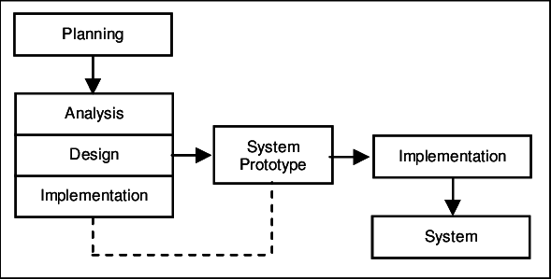

Figure 1: Architecture of the system

# 3.3 DATA COLLECTION METHOD AND USERS NEED

The development of this application while taking into account all of the demands and requirements for its execution is made possible by the architecture of our platform, which calls for the collection of a specific quantity of data and reliable information. As part of our research, we have chosen to gather information and ascertain users' demands through interview and observation.

# 3.3.1 OBSERVATION

We found a lot of inspiration in observation, which undoubtedly made us more anxious to gather information for the development of our online application. It was extremely simple to see how recording every book read could sometimes result in incorrect calculations and some alerts being completely missing. Most of the time, only to illustrate that this is an issue. Without a doubt, it was during the period of observation that the primary goals and objectives of this project were developed in order to address the issue raised manually without recording the number of books removed from the system.

# 3.3.2 INTERVIEW

The interview started with a description of the library and its goals, and the discussion centered on the operation of the library system. The response was that the library's everyday operations, including book circulation, book returns, and due date calculations, are managed and tracked by the library management system. The interviewer noticed a fairly serious issue in this response because a lot of time was lost trying to determine exactly how many books were removed. The relevance of this library system was emphasized during the interview as well. Here, a few aspects of the system's management of a library's manual operations were highlighted.

# 3.3.3 USERS NEED

A useful programmer would not create a web application without taking into account the needs of the consumers, thus a relevant web application should be built in accordance with those needs. After gathering information, we discovered that all library owners' proposals sought suitable, long-lasting solutions to issues that came up while conducting inventory for administering a library. Following interviews with representatives from both sides, several unmistakable findings emerged, particularly about the fact that students frequently choose to remain home instead of attending class because they don't want to waste time waiting for the teacher to show up. We investigated the system's operation and learned how it functions. We also tried out potential issues and their best solutions.

# 3.4 FUNCTIONAL REQUIREMENT

The functional requirement demonstrates the numerous fundamental computer parts required for our website to run smoothly and effectively for the target audience. Some prerequisites include:

* Sufficient RAM,
* A powerful processor, and
* A hard drive with peripheral input and output devices such the keyboard, mouse, and monitor.
* An up to date system

# 3.5 FUNCTIONAL SPECIFICATION

In the functional requirement, we are looking at the various tools used to build up the system.

These tools are;

# 3.5.1 ROLE PAYED BY EACH AUTHOR

* **Librarian:**

They are the main actors of our system. This is because the system is functioning for their sake and rate. So, they need to log in to access books in the system. They are also in charge of the administration of the system where he monitors books taken out and put back into the system

• **Users:**

To the users, the system helps library institutes to manage library functions automatically. It helps reduce overheads and increase productivity.

**• Books :**

Books are stored in the library where the books can be accessed. The functional specification include actors which will interact to actually bring out the role of this application in inventories stock management and how this application will play this role with the help of its actors. This system has two main actors which are administrator and customer.

**The administrator menu involves;**

* **Admin** should be able to insert, modify, and delete books.
* **Can accept and reject** a new user according to the library system.
* Information Can get the information of any member who has borrowed a book.
* **Add and edit books** and arrange books by categories.
* **Can record** books returned by users
* **Book entry.** In this module, we can enter a new book and store it.
* **Book issue.** In this module we can issue a book to a new student.
* **Book record.** In this module we can keep the records of various books being issued and returned.

# 3.5.2 The System's Abilities

The fundamental functions of adding and deleting, issuing and returning books are made very simple by library administration software. Book reservations, cataloging, late notices, and indexing are all automated operations. The software technology streamlines the procedure and increases accountability.

# 3.6 TECHNICAL SPECIFICATIONS

* A login page for each actor in the system should be included on the main page.
* The platform should display an interface where the administrator and librarian can log in during the connecting phase.
* Each user will have their own home page with a unique menu after logging in, depending on the type of user and privileges they have.
* The website should be able to do the most fundamental tasks. These features allow the system to be flexible.

# 3.7 NON-TECHNICAL SPECIFICATION

* **Security level:** This platform should be able to secure users information very efficiently and ensure that the information isn’t made public for other users to see.
* **User friendly:** The platform should be very interactive, easy to use and easy to navigate since people of all legal ages would be able to access these platform
* **Availability:** The system is available to users at anytime, anywhere, they just need a pc, or a mobile phone and internet connection to access these books.
* **Responsiveness:** This simply means that the platform should be compactible to any device trying to access it such as Desktops, Laptops, Mobile phone and also tablets.
* **Flexibility and easy access of the platform;** At all times, the web platform should be able to respond to any demand by the librarians.

**Non-Technical specification**

**• Flexible to use**

The web application should be able to track all those who are in the system and the activities being carried out.

**• Performance level**

The internet connection should be extra fast with a high bandwidth.

**• At the level of security**

Like any web application that we have the chance to visit the administrators won’t be able to log in to any other administrators account without prior authorization from the administrator. Here, each administrator account is confidential to him or her.

# 3.8 RESEARCH DESIGN

The research design for this system here is required to solve some complications faced by the librarians so as to be effective in the library system. Some of the difficulties faced by the user are;

**Some of the importance of the system is shown below**

* **Easy to update**: One of the major reasons for people to stick to their old system is because there are familiar with it. The library management system takes this out of the equation. Subsequently these systems are extensively easy to use and update.
* **It’s fast**: The system makes the process way faster than before, while the do work to carry out calculations themselves. Undergoing calculations will be a matter of a second.
* **Convenient**: One of the major facts of the Library Management System is that it makes the process very convenient for the users.
* **Easily accessible**: Implementing a library management system makes it easy for users to access the system easily where books could be gotten.

# 3.9 ANALYSIS METHODS

The researcher is guided by the scientific approach method to create acceptable software, and this method includes an analysis that results in the creation of a web application like this one. Use-case diagrams and use-case details are used to analyze the functional and non-functional requirements in this section. The class diagram and sequence diagram are also included. We will discuss the many sorts of methods, including both object-oriented and functional methods. At the conclusion, we will specify the approach that is ideal for realizing our system and provide the justifications for our decision.

# 3.10 OBJECT- ORIENTED MODELING

Using the object-oriented paradigm throughout the whole development life cycle, object-oriented (OOM) is a popular method for designing applications, systems, and business domains. In contemporary software engineering, OOM is a key approach that is heavily utilized by both OOD and OOA activities.

Under the broad category of object-oriented methods and functional methods, we shall go step by step to examine the many types of methods. At the conclusion, we will specify the approach that is ideal for realizing our system and provide the justifications for our decision.

We can cite the OMT method, UML method, and UP method as examples of object-oriented methods.

# 3.10.1 OMT METHOD

An object modeling approach for designing and modeling software is called the Object Modeling Technique (OMT). Rumbaugh, Blaha, Premerlani, Eddy, and Lorensen created it in 1991 as a technique for creating object-oriented systems and promoting object-oriented programming (ESPINASSE, 1980). OMT was created as a way of constructing software. Rumbaugh cites the following goals for this modeling: Conception (alternative information presentation); Communication with the librarians; Testing physical entities before developing them (simulation);

Decrease in complexity

**OMT has proposed three main types of models:**

**Object model:** The object model represents the static and most stable phenomena in the model domain. Main concepts are classes and associations with attributes and operations.

Aggregation and generalization (with multiple inheritances) are predefined relationship.

**Dynamic model:** The dynamic model represents a state or transition view on the model.

Main concepts are states, transition between states and event to trigger transitions. Actions can be modeled as occurring within states. Generalization and aggregation (concurrency) are predefined relationships.

**Functional model:** The functional model handles the process perspective of the model, corresponding roughly to data flow diagrams. Main concepts are process, data, data flow, and actors.

# 3.10.2 UML METHOD

UML diagrams are diagrams based on the UML (Unified Modelling Language) with the purpose of representing the system along with its main actors, roles, actions, artifacts or classes, in order to better understand, alter, maintain, or document information about the system.

UML was created as a result of the chaos revolving around software development and documentation. In 1990s, there were several different ways to represent those systems and as a result, in 1994-1996, the UML was developed by three software engineers working at Rational Software. It was later adopted as the standard in 1997 and has remained the standard language ever since, receiving only a few updates. UML has been used as a general-purpose modelling language in the field of software engineering. However, it has now found its way into documentation of several business processes or work flows. For example, activity diagrams, a type of UML diagram can be used as a replacement for flowcharts. They provide both more standardized way of modelling work flows as Some advantages of UML.

Formal and standardized language, it allows proceeds of precision and constitutes a pledge of ability;

Powerful support of communication;

Implementation of all the richness of the object approach;

Description of all the model from the analysis to the realization of the software;

Standardization of the concept objects

**Some limits of UML are:**

Difficult optimization of the choice of classes;

The semantics of UML is not formalized. It is specified by using the natural language;

Various categories of diagrams are not formalized;

well as a wider range of features to improve readability and efficiency.

# 3.10.3 UNIFIED PROCESS METHOD

Unified process (up) is based on the enlargement and refinement of a system through multiple iterations, with cyclic feedback and adaption. The system is developed incrementally over time, iteration by iteration and thus this approach is also known as iterative and incremental software development. The iterations are spread over four phases where each phase consist of one or more iterations.

According to up, to transform the software needs of users, must necessarily have the following characteristics:

* UP is based on component
* Up uses UML
* UP is driven by uses cases
* UP centric architecture
* UP is iterative and incremental.

**Some advantages of the Unified process:**

1. Use case sensitive
2. Architecture centric
3. Iterative and incremental

**Some limit of the Unified Process**

* It is used only at the beginning of the whole process to create business requirements
* The final application reflects the businesses processes, but the exist no closer bond between them.
* A small change in the business process leads to a fundamental change of the created information system.

# 3.11 FUNCTIONAL METHODS

The functional methods have their origin in the development of the procedural languages. More directed towards the management of data, they highlight the functions to be ensured and propose a hierarchical, downward and modular approach by specifying the bonds between the various modules. With evolution of systems and programming languages, these methods took into account the modelling of the data and the problems arising from real time.

# 3.11.1 SADT METHOD

Structured analysis and design technique (SADT) is a system engineering and software engineering methodology to describe systems as a hierarchy of functions. Structured analysis and design technique (SADT) is a diagrammatic notation designed specifically to help people describe and understand systems. It offers building blocks to represent entities and activities, and a variety of arrows to relate boxes. These boxes and arrows have an associated informal semantics. SADT can be used as a functional analysis tool of a given process, using successive level of details. The SADT method not only allows one to define user needs for IT developments, which is often used in the industrial information systems, but also to explain and present an activity’s manufacturing processes and procedures

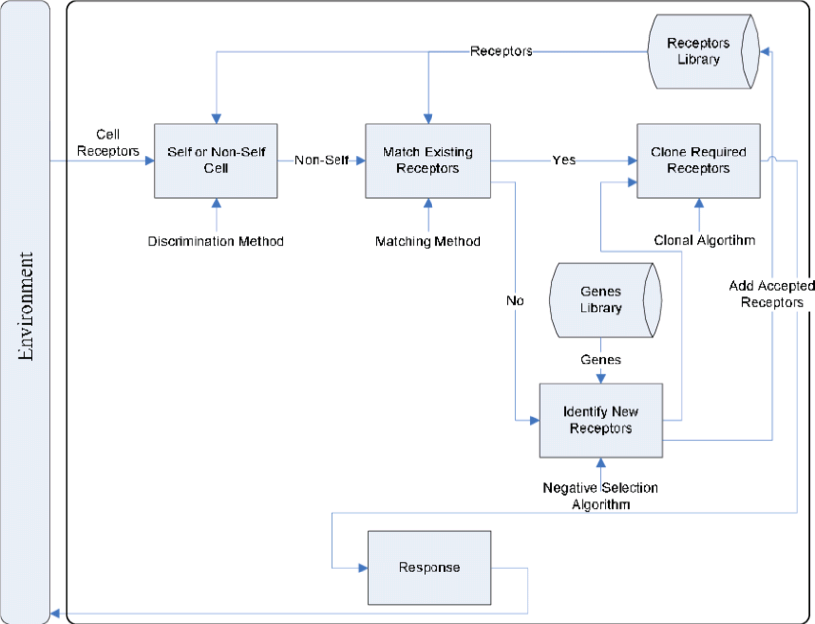

Figure 2: SADT Model

**Some advantages of SADT method are:**

-Its adequacy to capture the user’s needs

-Its capacity with being able to produce solutions on several level of abstraction

**Some limits of SADT method are:**

-Its analysis is concentrated much on the functions, the coherence of the data being neglected

-The rules of decomposition are not explicit. The decomposition differs according to analysis

-Its difficulties of taking account of the non-hierarchical interaction in the complex system

# 3.11.2 MERISE METHOD

MERISE is an Information System Design and Development methodology widely used in France it was launched aound1977 through a national consultation launched by the French Ministry of industry with the aim to create a company of data processing consultant in order to define a method of design of information system. The MERISE method is based on separation of data and treatments to be carried out in several conceptual and physical models.

The framework of MERISE has three cycles: abstraction cycle, approval cycle and life cycle.

The abstraction cycles the use of three database levels (conceptual, Logical and physical).

**Some advantages of MERISE method are:**

* MERISE is considered like a method of design of information systems on the plan of its general organization.
* MERISE allows the comprehension and the formalization of the needs for the trade
* MERISE support the dialogue between originator and owner, building particularly in the projects of integrated system development of management
* MERISE allows the general modelling of the data for construction of a database
* MERISE ensures the formalization of the users need within the framework of a schedule of conditions, before the wok is design.

**Some limitations of MERISE method are:**

In spite of its many advantages, the Merise method was often criticized as being a

Franco-French historical method. Its disadvantage can be analyzed around three points.

* MERISE is more turned toward the engineering of general design then towards the software genius.
* Difficulty in maintaining the system.
* Not an easily evolutionary system.

# 3.12 CHOICE OF METHOD

Choice of method here means the method we have chosen to come out with the system. As a methodology used in this work, UML has been chosen to design our application. Reason why UML is chosen is because in UML, the dynamic (behavioral) and static (structural) things based into the system’s entity to realize good and desirable results. This create interdependency between the static and the dynamic things. It also provides precision and stability of the system.

# 3.13 APPLICATION OF METHOD

We decided to use the UML because it is a pictorial standard and modelling mechanism for specifying, visualizing, constructing and documenting the artifacts of software system. So beyond reasonable doubts, UML will help us realize our application and understand its functionality.

# 3.13.1 ACTORS

An actor specifies a role played by a user or any other system that interact with the system but which is external to the subject. In our case we have the following actors:

* **Administrator:** The administrator is in charge of the administration of the system and also carrying out daily inventory transactions. Therefore, an administrator acts as an individual handling or doing the general overseeing of the system. The roles are identified as follows;
* Insert and register students and teachers in the system
* Add, edit librarians.
* Admin is in charge of those who remain in the system or not.
* Admin can change the password.

**Librarians/Admin:** There are the main actors of the system, they involve both the teacher and the students.

**Users:** The system helps in maintainingdata of books issued to learners and books available in the library. This helps librarians spot any particular book at any given time in the system.

**Results:** it is a software agent associated with the system that is design to give an output of the total books taken.

# 3.13.2 DIAGRAMS

1. **The Use case diagram**

The use case diagram is one which clearly shows all the actors in a given system and how those said actors interact with that system. This part contains the analysis of the functional and non-functional requirements using use case diagram and use case details.

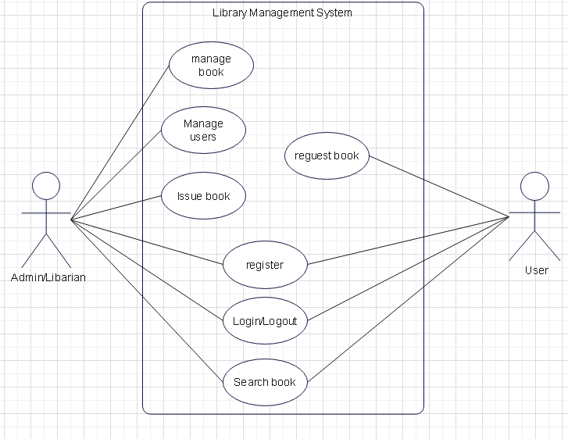

Figure 3:Use case diagram

From the above use case diagram, shows the student and teachers procedure entering into the system accounts before any other action is done. After logging into the system, the student and the teacher can manage the books found in the system books. The admin can also manage librarians and change his/her password in the system. As for the Admin, they can only login, view the books taken.

1. **Sequence diagram**

Sequence diagram as one of the interaction over view diagrams, emphasizes on time sequences of message flow from one object to another. The sequence diagrams are a type of universal modelling language (UML). They are used to show how objects in a system work together over time. A sequence diagram helps the designer of a system visualize and understand the order in which these interactions occur.

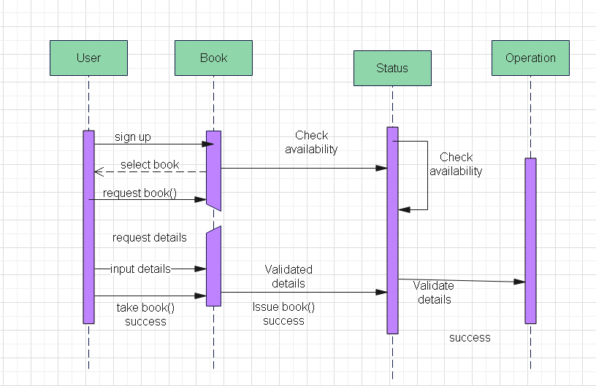

Figure 4:Sequence Diagram

1. **Class diagram for a library system;**

Library management system class diagram describes the structure of a library system. The diagram does this by showing each class and its attributes, methods and its relationships. Our library management system coordinates all the functions of a library. It manages how members search for and check out books.

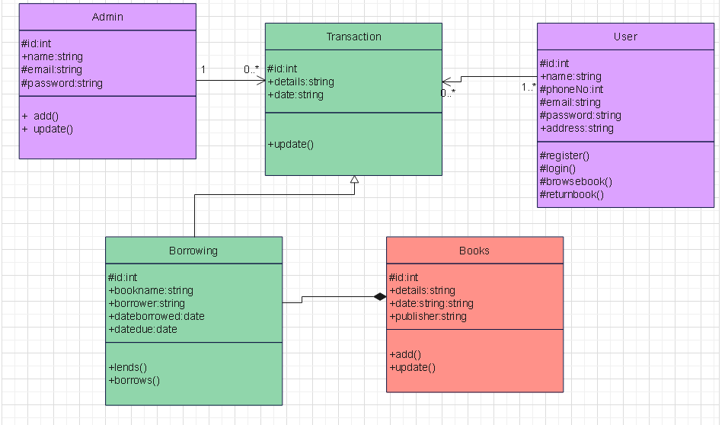

Figure 5:Component Diagram

**COMPONENTS OF THE SYSTEM**

Component of the system include modules which can be viewed on the result management system platform. The various components present in the system include:

**Login process into the system.**

This module contains two main functions,

**Libarian sign in:** This function is meant for the admin of the system.

**User sign in:** This function is meant for the librarians of the system to be able to access the system. That is both the Teacher and Student.

# 3.14 VARIOUS MODEL OF THE METHOD

# 3.14.1.1 DATA DICTIONARY

|  |  |  |  |  |
| --- | --- | --- | --- | --- |
| No | Reference | Significance | Type | Size |
| 1 | admin_id | Administrator’s identifier | int | 11 |
| 2 | admin_email | Administrator email | varchar | 200 |
| 3 | admin_password | Administrator password | varchar | 100 |
| 4 | user_id | User identoifier | in | 11 |
| 5 | user_name | User’s name | varchar | 200 |
| 6 | user_ email_address | User’s email address | varchar | 200 |
| 7 | user_password | User’s password | varchar | 30 |
| 8 | Author_id | Author identifier | int | 11 |
| 9 | Author_name | Author name | varchar | 200 |
| 10 | Author_status | Author status | Enum | ‘Enable’,’Disable’ |
| 11 | Author_created _on | Date of author creation | varchar | 30 |
| 12 | Author_updated_on | Date of author update | varchar | 30 |
|  | Book_id | Book identifier | int | 11 |
|  | Book_category | Book category | varchar | 200 |
|  | Book_author | Book author | varchar | 200 |
|  | Book_location_rack | Book location | varchar | 100 |
|  | Book_name | Book name | text |  |
|  | Book_isbn_number | Isbn number | varchar | 30 |
|  | Book_status | Book status | enum | ‘Enable’,’Disable’ |
|  | Book_added_on | Date book was added | varchar | 30 |
|  | Book_updated_on | Date of book update | varchar | 30 |
|  | Category_id | Category identifier | int | 11 |
|  | Category_name | Category name | varchar | 200 |
|  | Category_status | Category status | enum | ‘Enable’,’Disable’ |
|  | Category_created _on | Date of category insertion | varchar | 30 |
|  | Category_uodated_on | Date of category update | varchar | 30 |
|  | Issue_book_id | Identifier of the book issued | int | 11 |
|  | Issue_date_time | Date and time of issued book | varchar | 30 |
|  | Expected_return_date | Expected date for return | varchar | 30 |
|  | Return_date_time | Date and time of returned book | varchar | 30 |
|  | Book_fines | Book fine | varchar | 30 |
|  | Book_issue_status | Staus of the issued book | enum | ‘Issue’,’Return’,’Not Return’ |
|  | Location_rack_id | Location idntifier | int | 11 |
|  | Location_rack_name | Location name | varchar | 200 |
|  | Location_rack_status | Location status | enum | ‘Enable’,’Disable’ |
|  | Location_rack_created_on | Date of location creation | varchar | 30 |
|  | Location_rack_updated_on | Date of loction update | varchar | 30 |
|  | Setting_id | Setting identifier | int | 11 |
|  | Library_name | Library name | varchar | 200 |
|  | Library_name | Library address | text |  |
|  | Library_contact_number | Library contact | varchar | 30 |
|  | Library_one_day_fine | Book fine | int | 4 |
|  | Library_currency | Library currency | varchar | 30 |
|  | Library_timexone | Library timezone | varchar | 100 |

# 3.14.2 RULES TO MOVE FROM ONE DATA MODEL TO ANOTHER

**Rule 1:** Any entity becomes a table in which the attributes becomes columns. The identifier of the entity then constitute the primary key of the table

**Rule 2:** an association of the type 1: n disappears and becomes a foreign key of the table of the side 0:1 or which refer to the primary key of the other table

**Rule 3:** an association of the type n: n (that is which has positioned maximum cardinalities with

“n” on the two side of the association) results in the creation of a relation of which the primary key is made up of the foreign keys referring the relations corresponding to the entities bound by association

**Rule 4:** A binary association of type 1:1 is represented by a binary association of type 1:n. except that the foreign key is seen imposing a constraint of iniquity in addition to one possible constraint of vacuity.

**Rule 5:** Any non-association on the type 0: n can be seen as another table with primary key becoming all the foreign keys

The observation of the rule of passing from the CDM to the LDM enabled us to generate the following LDM. For our application, the can have the following LDM

# 3.15 SOFTWARE USED

There are various software used in producing the platform. The software include

**Visual Studio Code (Text editor used).**

This text editor was used to write all the codes for the system.

**Google Chrome**

Google Chrome was the web browser used to view all the html codes which were written.

**XAMPP SERVER**

This was the local server used to host the design and implementation of the library management system.

**PHPMY ADMIN**

This was the MYSQL administration tool used in the creating and handling all the database of the design and implementation of inventory stock management system website

**YOUTUBE**

YouTube was used to watch research videos on how the system could be built.

**E-DrawMax**

This app as used in drawing various logical diagram, like the activity diagram, sequence diagram, UML class diagram.

# 3.16 PROGRAMMING LANGUAGES USED

**HTML5:** HTML5 which stands for hypertext markup language was used to develop this system.

**CSS:** Which is the cascading style sheet was used to bring out a good style for the system to have a good presentation.CSS stand for Cascading Styles Sheets is used to add beauty (styles) to content displayed on web pages. CSS enhanced the layout of the web site and make the site look more attractive.

**PHP:** itis a server-side language which was used. This contains thousands of codes which are added to link the website to the server.

**JAVASCRIPT:** JavaScript was released by Netscape and Sun microsystem in 199.

JavaScript is a programming language, an interpreted language, object-based programming. It is a script-client side language used for interactive web pages.

# 3.17 HARDWARE USED

The following hardware tools were used in the implementation of the Design and implementation of inventory stock management system:

**COMPUTER**

**A** Windows 10 computer was used in implementing the system. The computer has a hard disk space of 256 Gigabyte, a Ram of 4 Gigabyte, a 64bit operating system with a processor of

1.90GHz.

**MODEM**

A Huawei was used for internet access.

Bookswere read to carryout research.

# 3.18 MODULES OF THE DESIGNED SYSTEM

The website would be developed with the help of the following

* A database management system placed in a local server (XAMPP server)
* A website which will interact with the database server. This website will present the following modules:
* Common home or landing page
* A module to login the admin, the teacher and the student.
* A module for an admin to change password if they have forgotten the previous one.

# CHAPTER 4: PRESENTATION ANALYSIS AND PRESENTATION OF RESULTS

# 4.1 INTRODUCTION

The results and discussions of our web application are the main emphasis of this chapter since we have covered every aspect of the methods utilized to create our system. The purpose of a library management system is to control the flow of books and keep track of the library's patrons. The administrators and librarians are the system's two primary users. When using the system, each user can carry out a variety of tasks. These features were chosen in accordance with the system's design, which included a user-friendly feature to increase the system's effectiveness and efficiency.

Figure:

|  |  |
| --- | --- |
| ACTORS | FUNCTIONS |
| **ADMIN** | * Log In/Out * Add new books * Post books and updates * Manage book, users, |
| **USER** | * Log In/Out * Search for the books |

# 4.2 RESULTS

Results here means what we finally have as findings of the outputs of the system.

# 4.3 PRESENTATION OF SCENARIOS

We shall display print screens of the various modules and give their functionality in order to better understand the relationship between customer’s webpage and that of the administrator

# 4.3.1 Add book Page.

To investigate if an administrator can successfully register a new book into the system

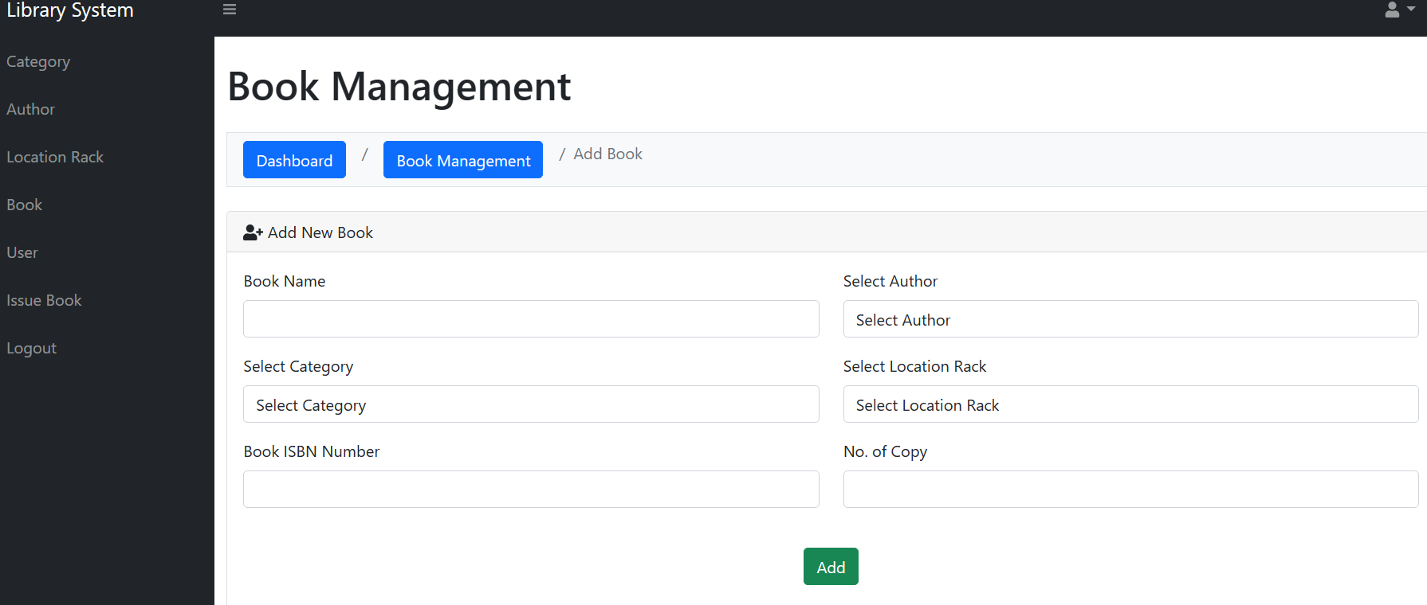

Figure 6:Add book page

# 4.3.3 Issue book Page.

To investigate if a student can successfully sign out a book with the help of the system admin.

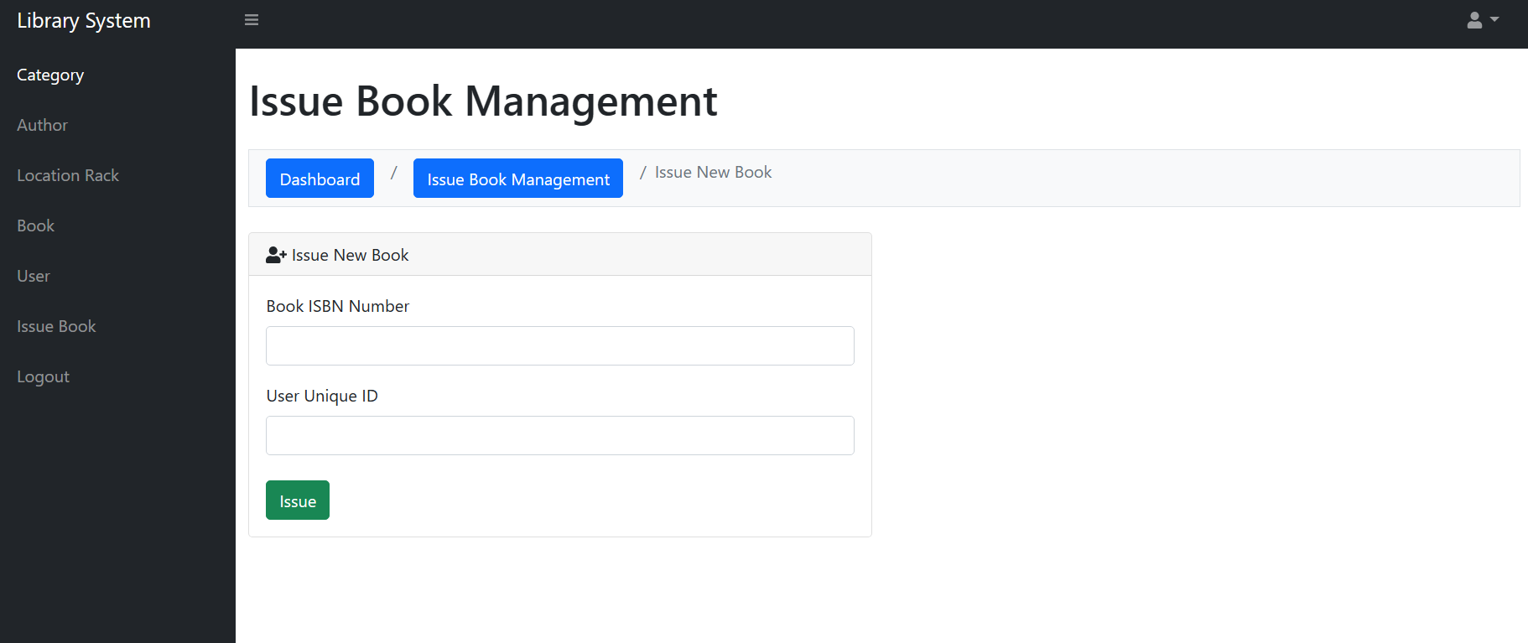

Figure 7:Issue book page

# 4.3.4 Search book page

To examine how fast a book search can be carried out on a system when a particular book is to be signed out.

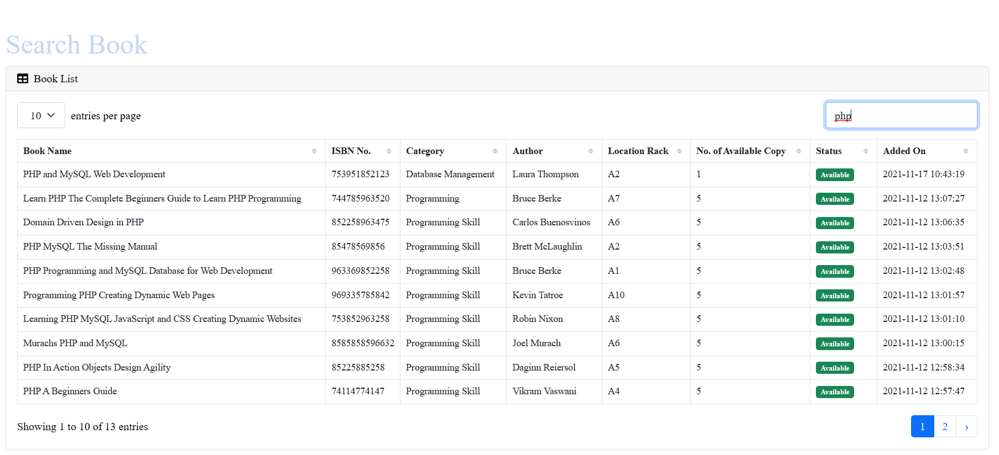

Figure 8:Search book page

# CHAPTER 5: DISCUSSION, CONCLUSION AND RECOMMENDATIONS

# 5.1 SUMMARY OF FINDINGS

Computerization of the library administration system is required to improve productivity and decrease human error. A computerized management system created to maintain all of a library's everyday operations is the management system that is offered in this proposal. All of the data about books and users is stored by library management systems. The main focus of this project is to lessen human effort and encourage efficient record keeping.

# 5.2 DIFFICULTIES ENCOUNTERED

This was due to the software's need for time and focus throughout the system's development because building this website required expertise of a wide range of computer languages, including HTML, CSS, and PHP. This made research to be slow and changes on the system to be implemented very slowly.

# 5.3 RECOMMENDATION

Information data expands quickly when management systems are widely used. On the one hand, there are many informational resources available to people. From the library system's recommendations, it examines important technologies and conducts application research on a content- and collaborative-based book recommendation system. A central database should be set up by the system to store all of the library's books. Obtaining the records necessary for proper library management, easy monitoring, and decision-making. To ensure proper management of the library system, a management procedure needs to be implemented.

# REFERENCE

Piotrowski, C., & Kowalczyk, B. (2015). Advantages and disadvantages of library management systems. TransInformação, 27(3), 217-227.

Al-Ghassani, W., Al-Kalbani, H., Al-Jabri, I., & Al-Manthari, A. (2018). Library automation: Evaluating the implementation of library management systems in public libraries. Journal of Librarianship and Information Science, 50(1), 51-64.

Devi, K., & Singh, Y. (2017). Library management software: a review of current trends and developments. DESIDOC Journal of Library & Information Technology, 37(3), 196-202.

Sahu, S. K., & Dey, N. (2013). Library management software: A review of literature. Indian Journal of Applied Research, 3(4), 156-159.

Sun, Y., Zhong, J., & Hu, Q. (2018). The design and implementation of a library management system. Journal of Intelligent & Fuzzy Systems, 35(1), 883-891.

Zhang, M., & Zhao, J. (2020). Research on the digitalization of university library based on library management system. Education Reform and Innovation, 13(1), 1-5.

Kumar, S., & Joshi, Y. (2012). The impact of library management system on library operations and services: a case study. The Electronic Library, 30(1), 72-85.

Moradmand, M., & Salehi, M. (2012). The impact of automation on the quality of library services. Library Philosophy and Practice (e-journal), 747.

Arora, J., & Gupta, V. K. (2015). Impact of library management system on library operations and services: a case study of Punjab University Library, Chandigarh. International Journal of Humanities and Social Science Research, 4(1), 7-15.

Kumar, S., & Joshi, Y. (2012). Impact of library management systems on library operations and services: a case study. The Electronic Library, 30(6), 795-810.

Moradmand, F., & Salehi, M. (2012). The effect of the library management system (LMS) on service quality in academic libraries. Library Philosophy and Practice, 1-10.

Arora, S., & Gupta, S. (2015). Impact of library management systems on library operations and services: a case study of IIT Delhi. DESIDOC Journal of Library & Information Technology, 35(4), 251-256.

Robertson, J. (2004). Library management system. In M. Khosrow-Pour (Ed.), Encyclopedia of Information Science and Technology (pp. 1873-1877). IGI Global.

# APPENDIX

**Source code in the application that helps to add a book**

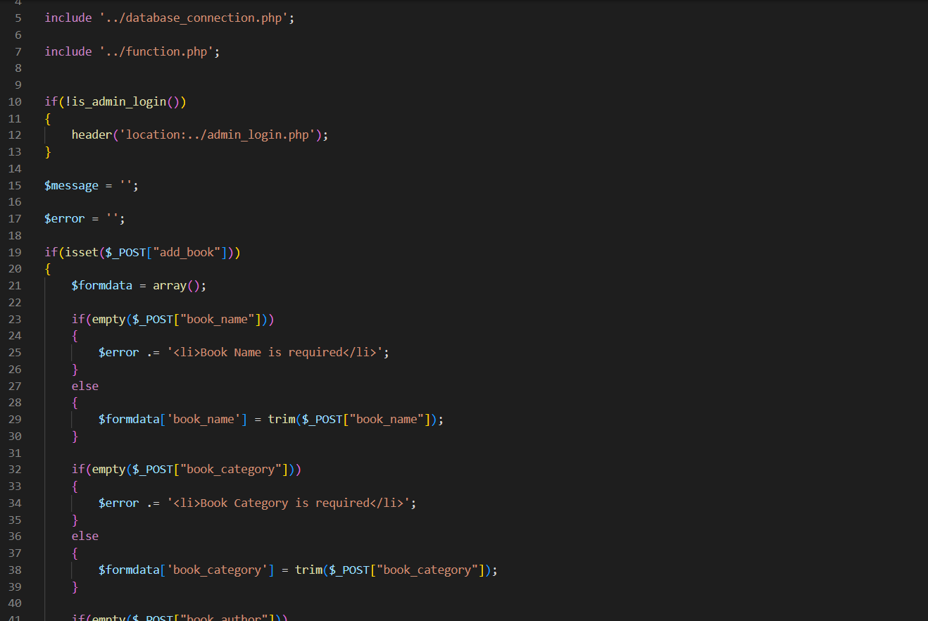

Figure 10 Add book code

**Source code in the application that helps Issue books**

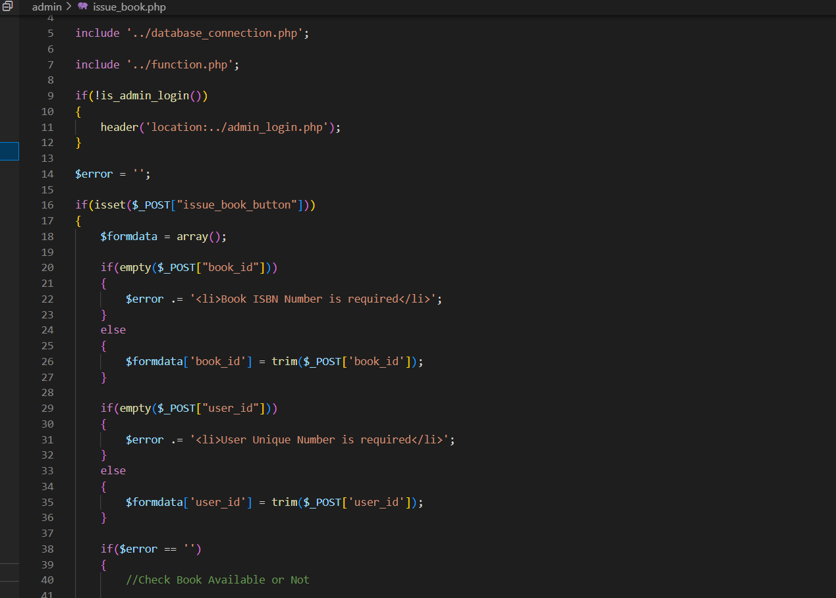

Figure 11: Issue book code

**Source code in the application that helps Search books**

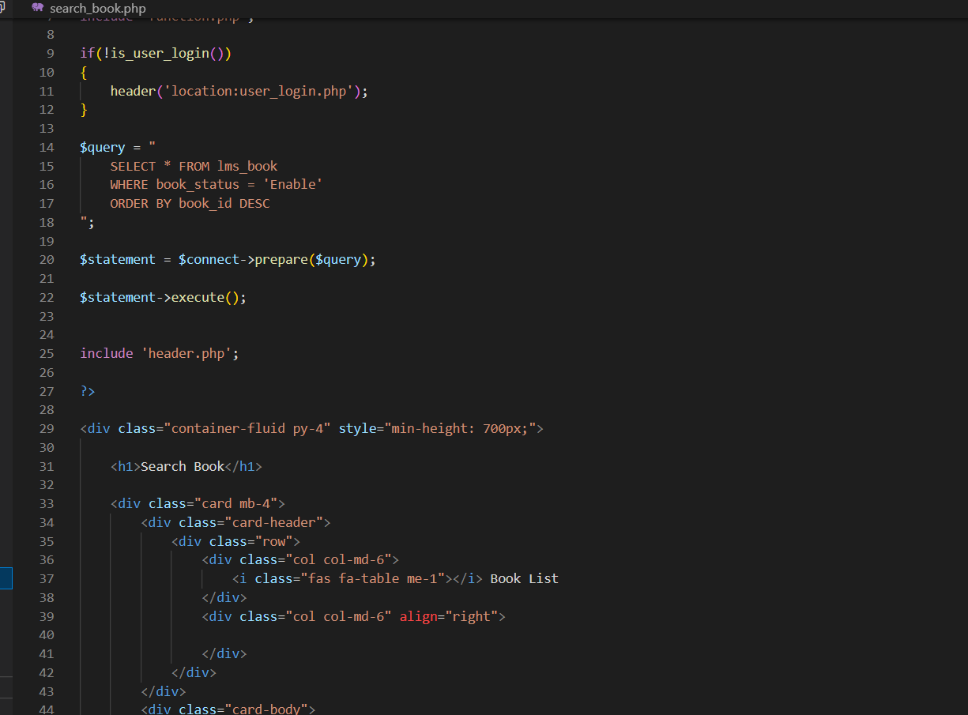

Figure 12: Search book code